# RequestDispatcher Interface

The RequestDispacher interface provides the facility of dispatching the request to another resource it may be html, servlet or jsp.This interface can also be used to include the content of antoher resource also. It is one of the way of servlet collaboration.

There are two methods defined in the RequestDispatcher interface.

### Methods of RequestDispatcher interface

|  |
| --- |
| The RequestDispatcher interface provides two methods. They are:   1. **public void forward(ServletRequestrequest,ServletResponse response)throws ServletException,java.io.IOException:**Forwards a request from a servlet to another resource (servlet, JSP file, or HTML file) on the server. 2. **public void include(ServletRequestrequest,ServletResponse response)throws ServletException,java.io.IOException:**Includes the content of a resource (servlet, JSP page, or HTML file) in the response. |

### How to get the object of RequestDispatcher

|  |
| --- |
| The getRequestDispatcher() method of ServletRequest interface returns the object of RequestDispatcher. Syntax: |

#### Syntax of getRequestDispatcher method

 getRequestDispatcher(String resource);

### *Example of RequestDispatcher interface*

|  |
| --- |
| * **index.html file:** for getting input from the user. * **Login.java file:** a servlet class for processing the response. If password is servet, it will forward the request to the wel.html. * **Wel.html** |

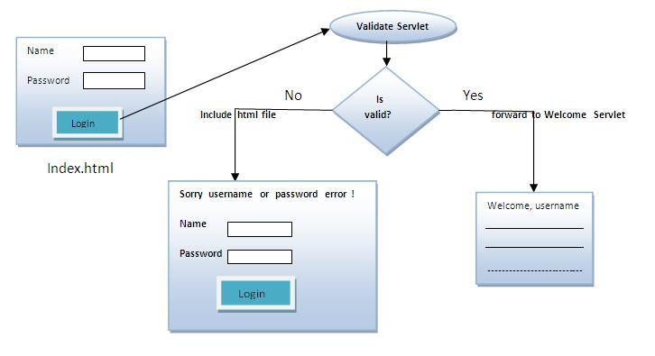

**index.html**

<form action="Login" method="post">

Name:<input type="text" name="N1"/><br/>

Password:<input type="password" name="p1"/><br/>

<input type="submit" value="login"/>

</form>

**Login.java**

1. **import** java.io.*;
2. **import** javax.servlet.*;
3. **import** javax.servlet.http.*;

**public** **class** Login **extends** HttpServlet {

**public** **void** doPost(HttpServletRequest request, HttpServletResponse response)

      {

  try

{

    response.setContentType("text/html");

    PrintWriter out = response.getWriter();

    String n=request.getParameter("N1");

    String p=request.getParameter("P1");

**if**(p.equals("adminadmin")

{

        RequestDispatcher rd=request.getRequestDispatcher("wel.html");

        rd.forward(request, response);

    }

**else**{

        out.print("Sorry UserName or Password Error!");

        RequestDispatcher rd=request.getRequestDispatcher("index.html");

        rd.include(request, response);

        }

    }

}

**Wel.html**

**<body>**

**Welcome**

**</body>**